Social Gaming Praktikum

Summersemester 2015

Campus Conquest

Documentation Fragment

Executing the Application

Michael Sailer

Jonas Mayer

Paul Preißner

Jean-Paul Vieira

Benedict Drechsler

Julian Frattini

Praktikum Social Gaming

Introduction

This documentation fragment explains how to set up the components in order to successfully run the application CampusConquest on any device. Since a few things changed from the *Rahmenprogramm* during the development process, this might come in handy.

Setting up the Server

Since the server has been redone completely a guidline to set up the server might be necessary.

Open any version of *Eclipse (IDE)*. Select *File > New > Java Project* and toggle of *default location.*

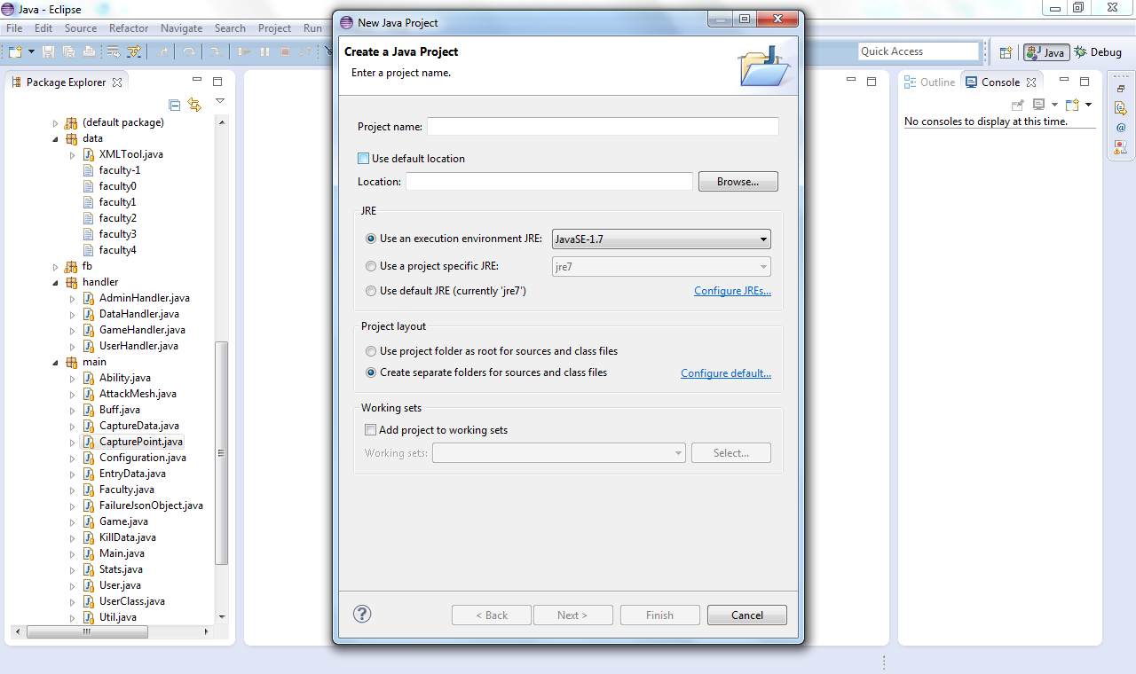

Instead, *Browse* for the folder *Server* in our GitHub repository.

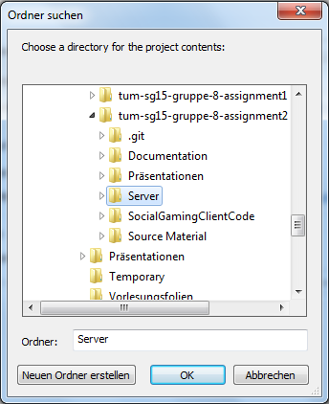

Once pressed *OK* and *Finish*, a folder called server should pop up in the Package Explorer of Eclipse. Please do not rename the project – leave it with *Server*, otherwise problems will occur.

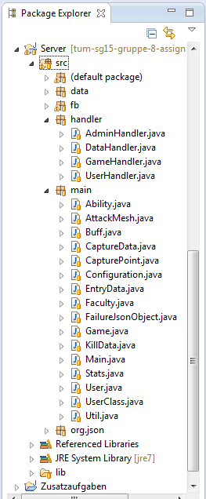

The structure of the folder should look somewhat like shown on the left.

Now simply open the class *Main* and run it in Eclipse.

Since the server stores gamedata in xml-files, it is recommended to reset these for testing purposes in order to have a fresh start. This can be done by deleting all faculty-files in data. All files (from faculty-1 to faculty4) have to be deleted.

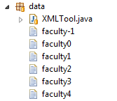

Once these 6 files are deleted, the server will be able to start from scratch. This is highly recommended. The feature to store game data between sessions is a long-term feature and only suitable for a published version of the game.

Once the server is running, the console should look like this:

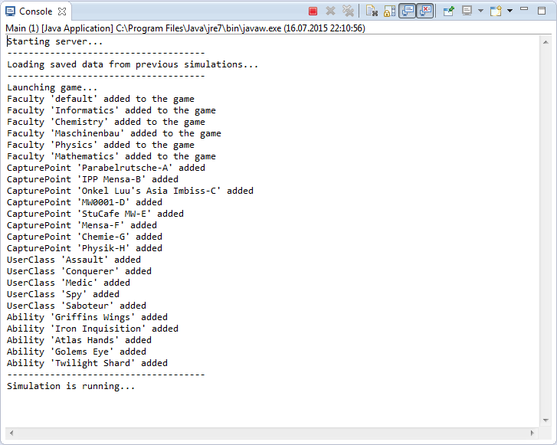

Nearly every call and every simulation on the server is documented with a prompt in the console, so that almost every step the server does can be viewed in this log.

*Final note*: The server is meant to run locally. The current port is 9097 and can be changed freely in the class *Configuration*.

Setting up the Client

The client setup is pretty much still the same as in the *Rahmenprogramm*. Just import the project in Android Studio, configure the server IP in Configuration.java with Port 9097 (if not altered in the server configurations), connect your Android-smartphone and press play ☺

